**Classroom Activity: Write a code to delete one document or multiple documents from MongoDB collection.**

**Code: delete one document from the collection.**

FoodDelivery> // Delete the document where the vendorName is "Yummy Foods"

FoodDelivery> db.vendors.deleteOne({ "vendorName": "Yummy Foods" })

**OUTPUT:**

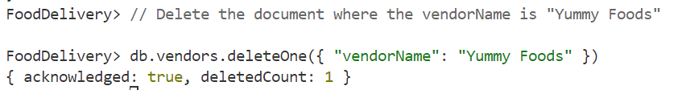

**Code: delete multiple documents from the collection.**

FoodDelivery> // Delete all documents where the cuisines include "Mexican"

FoodDelivery> db.vendors.deleteMany({ "cuisines": "Mexican" })

**OUTPUT:**

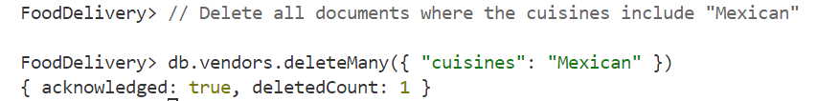

**Execution Steps:**

1. Install MongoDB compass and MongoDB shell
2. Create a new connection in MongoDB Compass
3. Create a new Database eg.)Food Delivery
4. Go to Visual Studio Code
5. Install the MongoDB for VS code extension
6. Click on the MongoDB icon on the navigation pane
7. Right click on the localhost:27017 connection
8. Select Launch MongoDB shell
9. Finally execute the above code.